How to Build a Linkbot Soccer Field
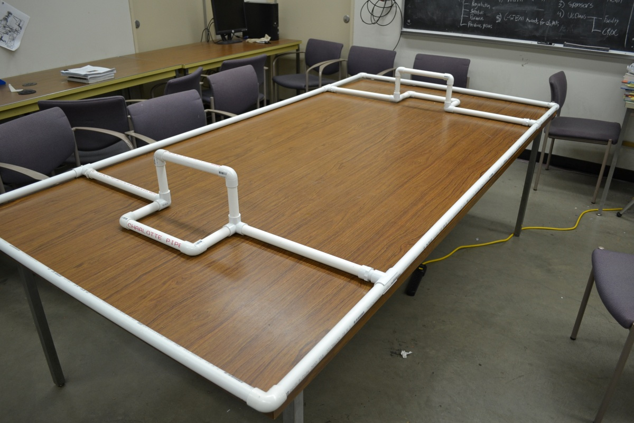

PVC Pipe:
All pipe is ¾" diameter
LENGTH | QUANTITY
8 feet | 2
4 feet | 2
17 inches | 4
10 inches | 4
5 inches | 8

Connecters
TYPE | QUANTITY
Elbow | 12
Three Way Corner | 4
Snap-on T | 4

Approximate cost of pipe and connectors: $40

Play will be enhanced if the above is placed on a 4' x 8' MDF board; approximately $30. This is not necessary, however.

Assembly instructions

- The total pipe length is 36'4". Hardware stores generally sell pipe in 10' segments. Purchase 4 of these segments and cut the pipe into to the proper lengths. Hardware stores will occasionally have a pipe cutter on site for you to use but you may have to purchase one for about $10.

- Using the two 8' pipe lengths, the two 4' pipe lengths and 4 of the elbow connectors, create the perimeter of the field.

- Using two 17" pieces, two 10" pieces, four 5" pieces, 4 elbow connectors and 2 three-way-corner connectors construct the goal assembly shown below. The two pieces on the far left and far right of the picture are 17". The crossbar and the bottom rear of the goal are 10". The four remaining supports are 5". Repeat this step twice.

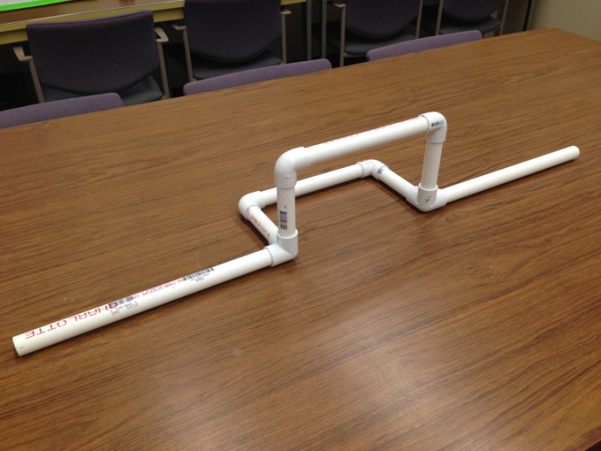

- Snap the four snap on T connectors to the outer walls of the field and insert the ends of the goal assembly to them.

- Enjoy the soccer field!

