Camp 1
Location: Lee Middle School
Time: 8am – 12:30 pm
Room: 6
Date: June 15th – June 28th

Camp 2
Location: Douglass Middle School
Time: 8am – 12:30 pm
Room: B1
Date: July 5th – July 15th

C-STEM GIRL Camp Directors: Jessica Graves, LMS Math Teacher and Naomi Bahr, WHS Math Teacher
C-STEM Girl Camp Coaches: Current University Student from UC Davis
Site Sponsors: Yolo County Office of Education, Woodland Joint Unified School District, C-STEM Center
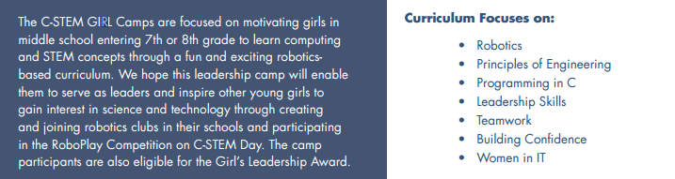

Girls Summer Robotics Camp Student Application

Please check which camp you would like to attend:
 Camp 1 at LMS June 15th – June 28th  Camp 2 at DMS July 5th – July 15th
Student Name/Information:
First: | Last: |  | MI:
School: |  | District:
Email (print neatly): |  | Phone:
Please tell why you are interested in attending the Girls Summer Robotics Camp:

Do you have any experience with computing or robotics? If so, what experience?

Application Process:
- Complete the student information portion.
- Detach the top (keep for your records).
- Give your application to a Math, Science or Computing teacher to have them complete the recommendation. They will submit your application.
- You will be notified by June 8th if your application was accepted.
Application Deadline: Please note the application deadline is JUNE 1, 2016
Contacts: LMS - Jessica Graves, jessica.graves@wjusd.org DMS - Naomi Bahr, naomi.bahr@wjusd.org

Teacher Recommendation Form – Name of teacher completing recommendation (print)
Ranking Scale:
Please evaluate the student listed above on the following scale:
5 Exceptionally high
4 Above Average
3 Average
2 Below Average
1 Deficient

Ability and Personality Traits: | 1 | 2 | 3 | 4 | 5
Personal Integrity:
Ability to Work with Peers:
Ability to work with Teachers:
Leadership Qualities:
Oral Communication Skills:
General Academic Performance:

Additional comments regarding student:

Signature of Teacher Completing Recommendation form: Date:

Where to Send the Application:
Lee Middle School applications to Jessica Graves at Lee Middle School by June 1st
Douglass Middle School applications to Naomi Bahr at Woodland High School by June 1st

Please send via district mail.
Thank you for taking the time to fill this out on behalf of the student.

